***Online Insurance System***

Online Insurance System (OSI) is a Web Page Application Module. People can use this site for Registration, Login, Policy Creation, Premium Payment, closing and Logout.

Flowchart of online insurance system just to know the simple data flow or to know how the data will flow in entire network.

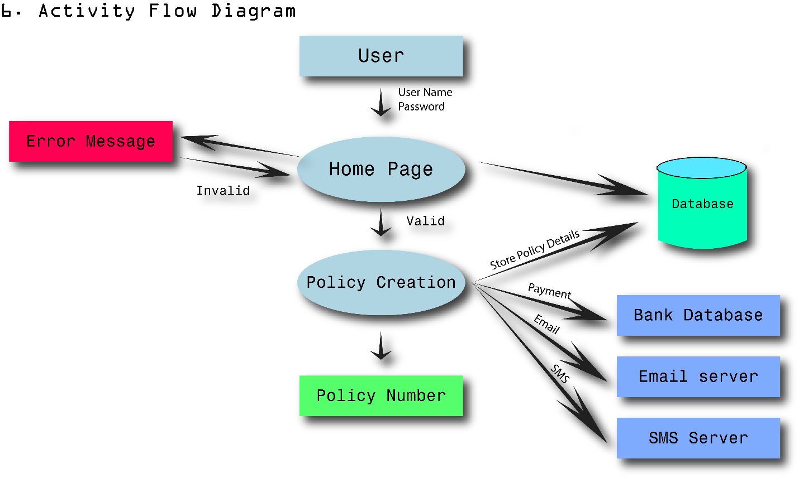

**Functional Requirement Specification**

Spe

Functional Specification Registration Module

In general people can launch OIS site to get Home page. Home page consist of registration Link’’. People can click this link to get registration page.

This page Consist of below Fields

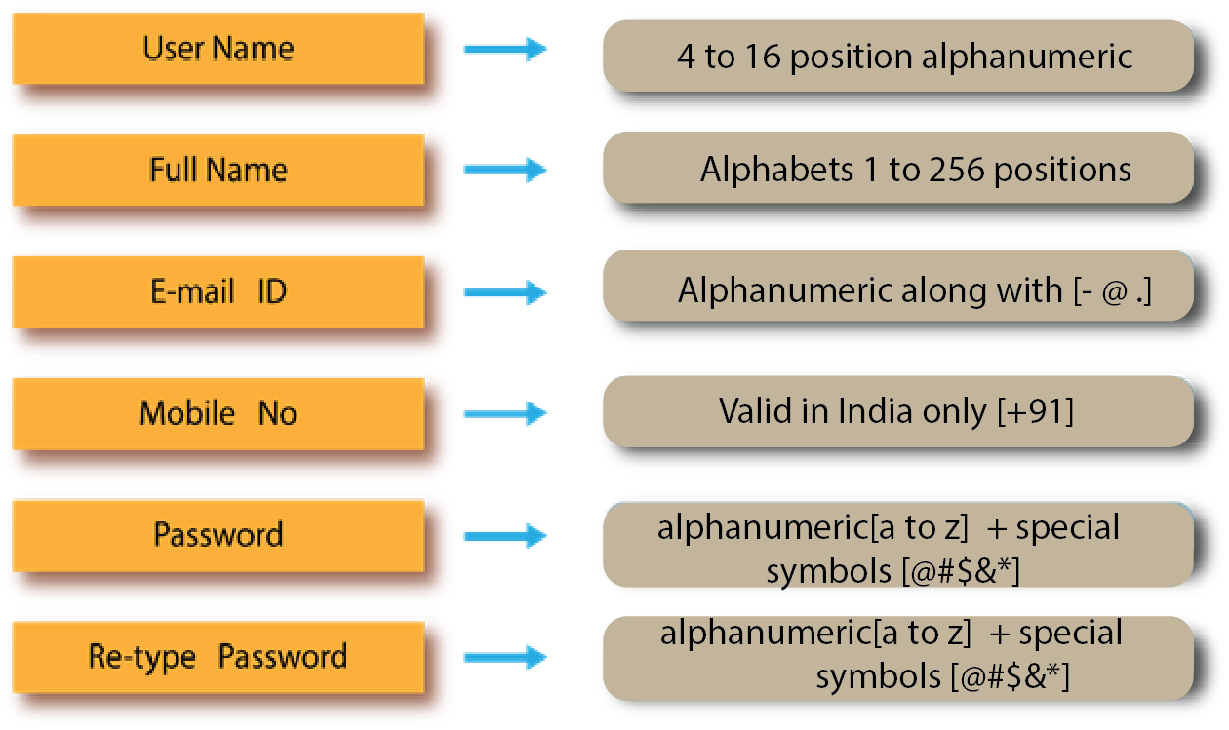

After filing above fields, People can click Submit button in Registration Page to get Successful

message along with Login Page or Home Page.

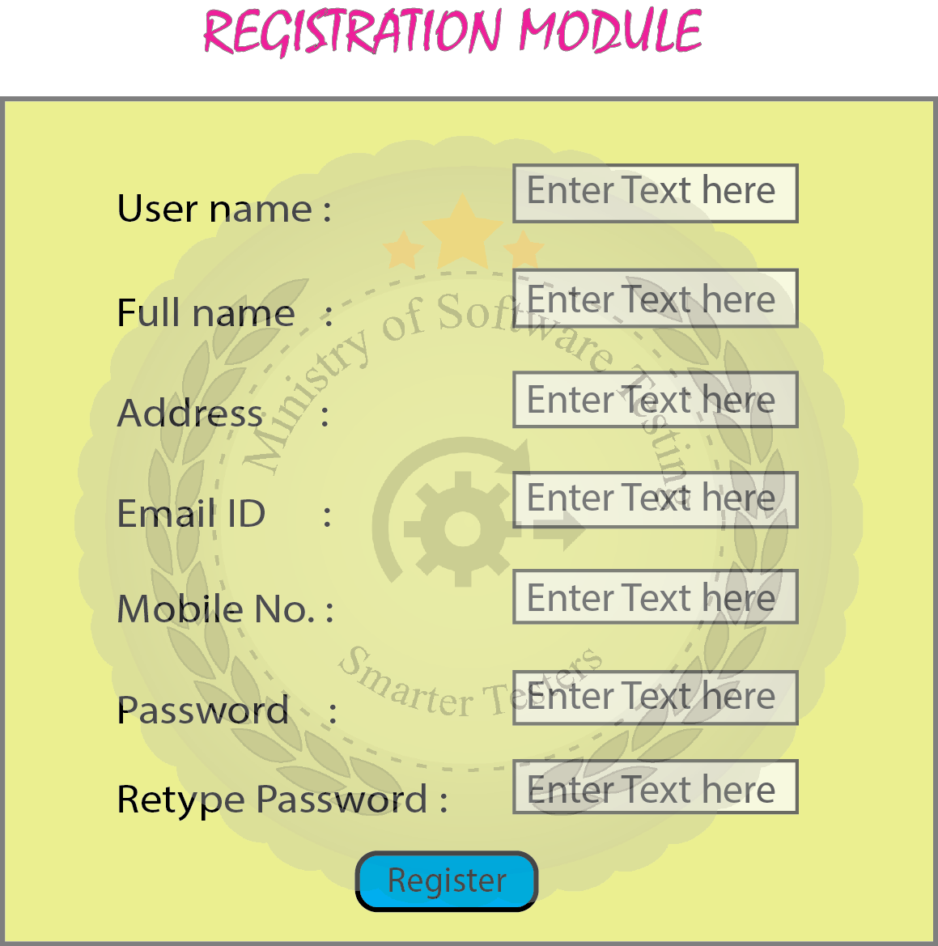

Functional Specification Login Module

Login Modules: In Online Insurance System(OIS), User can get login window with “Registration

Button” and Login Control like “User Name” and “Password”.  
New User can click Registration Button for Registration. Existing User can fill “User Name” and “Password”.

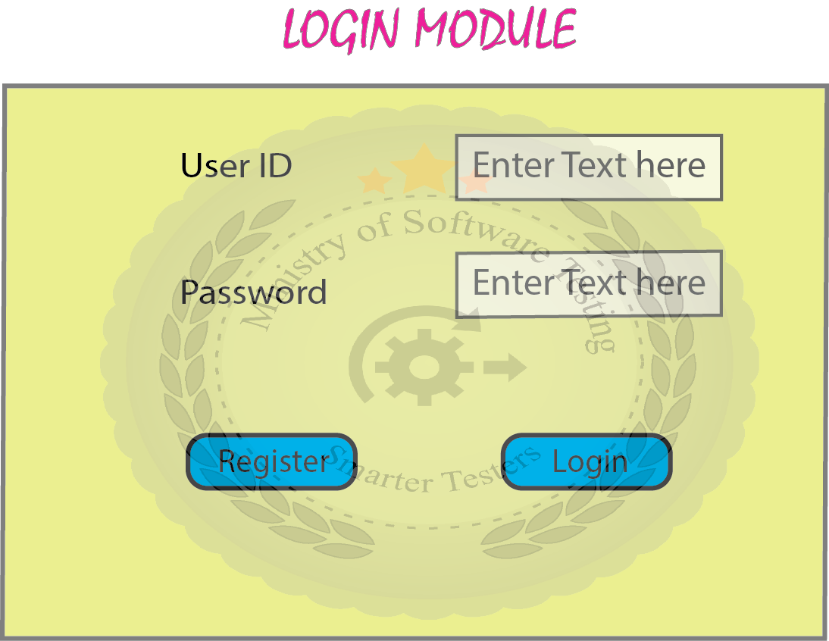

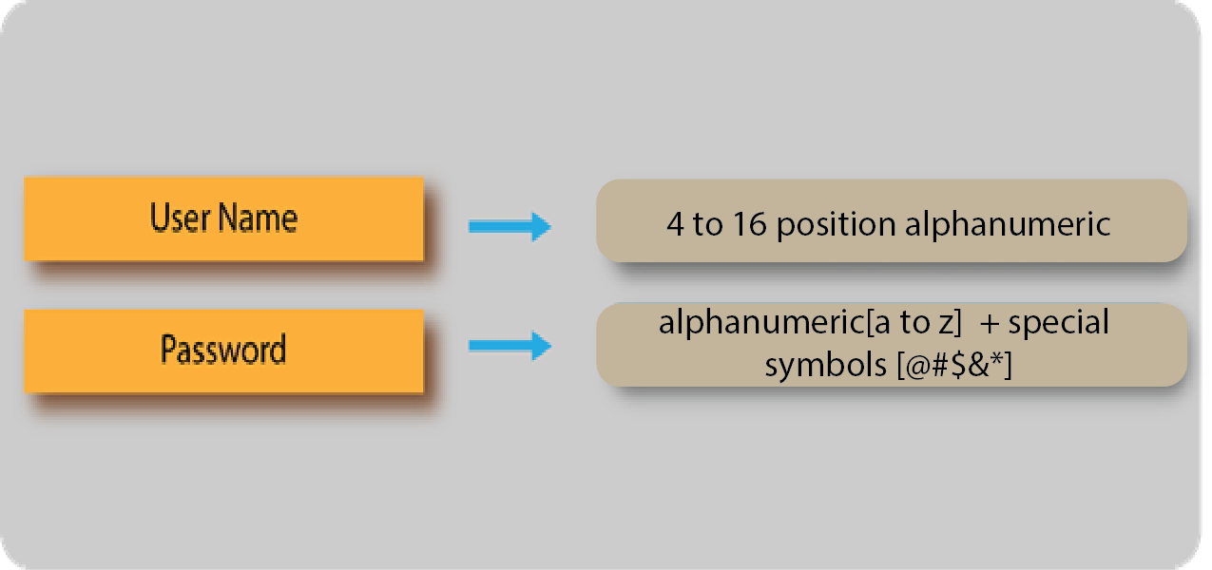

After filling the above Filled User can click “OK” button to get option window for valid data and

Error Message for Invalid data. User can use “Close Button” to Close Login window at any time.

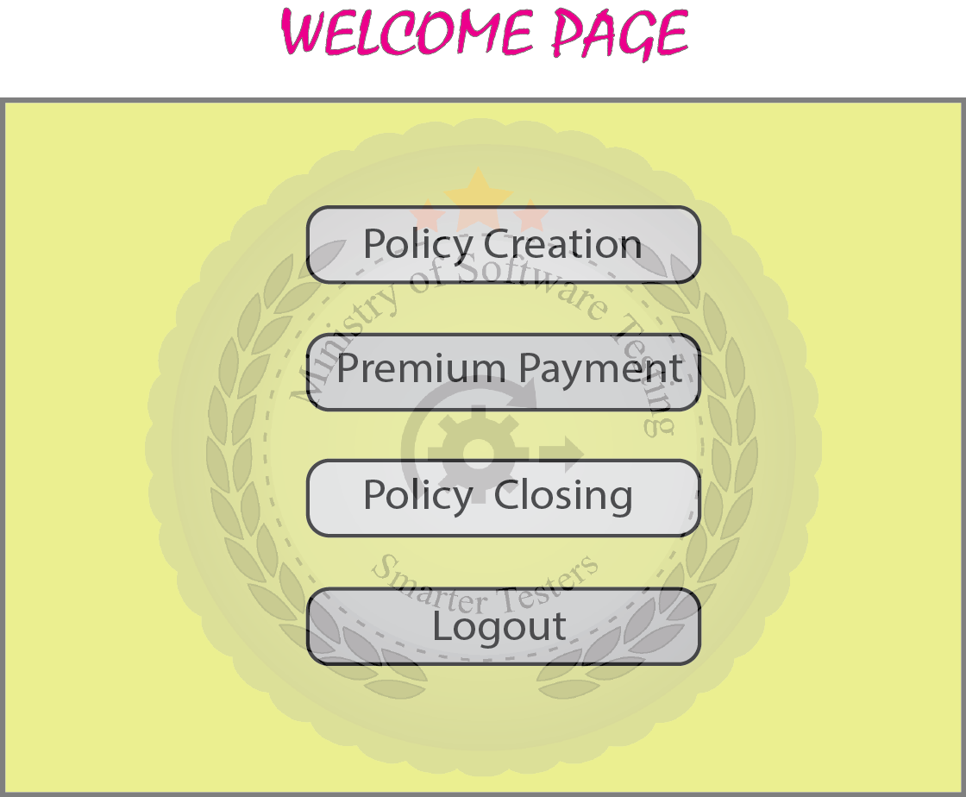

Use case for Policy creation module

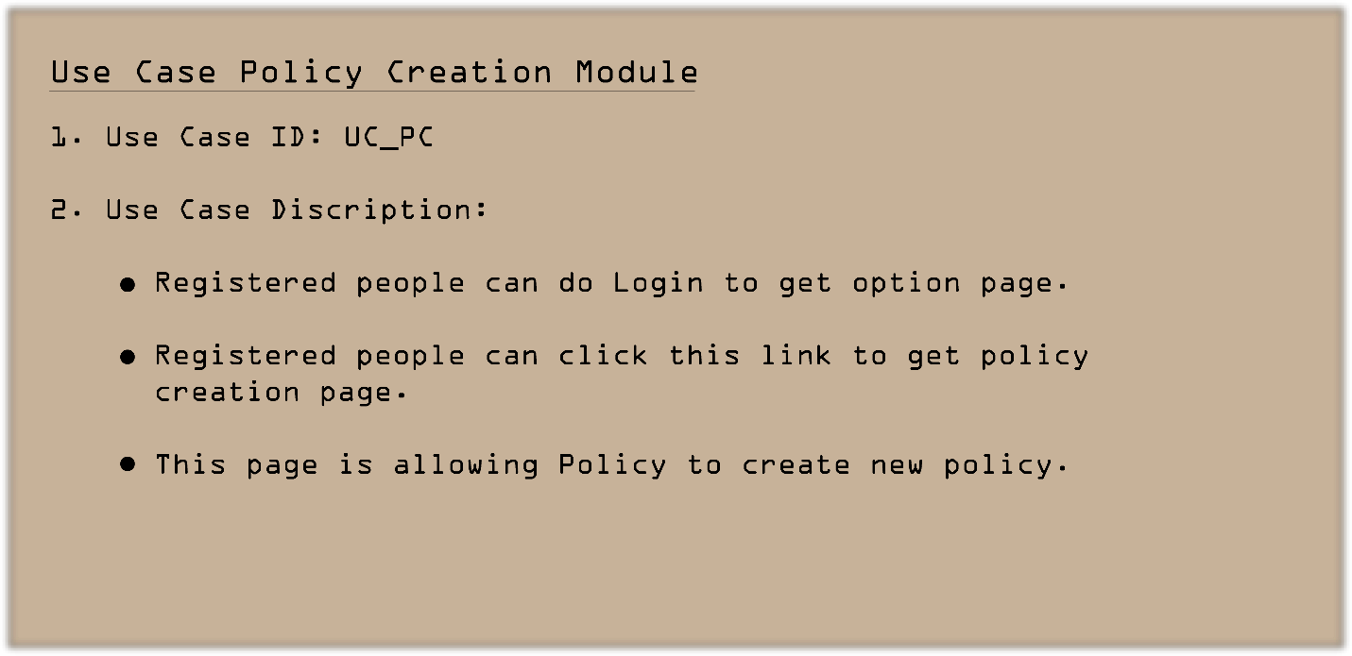

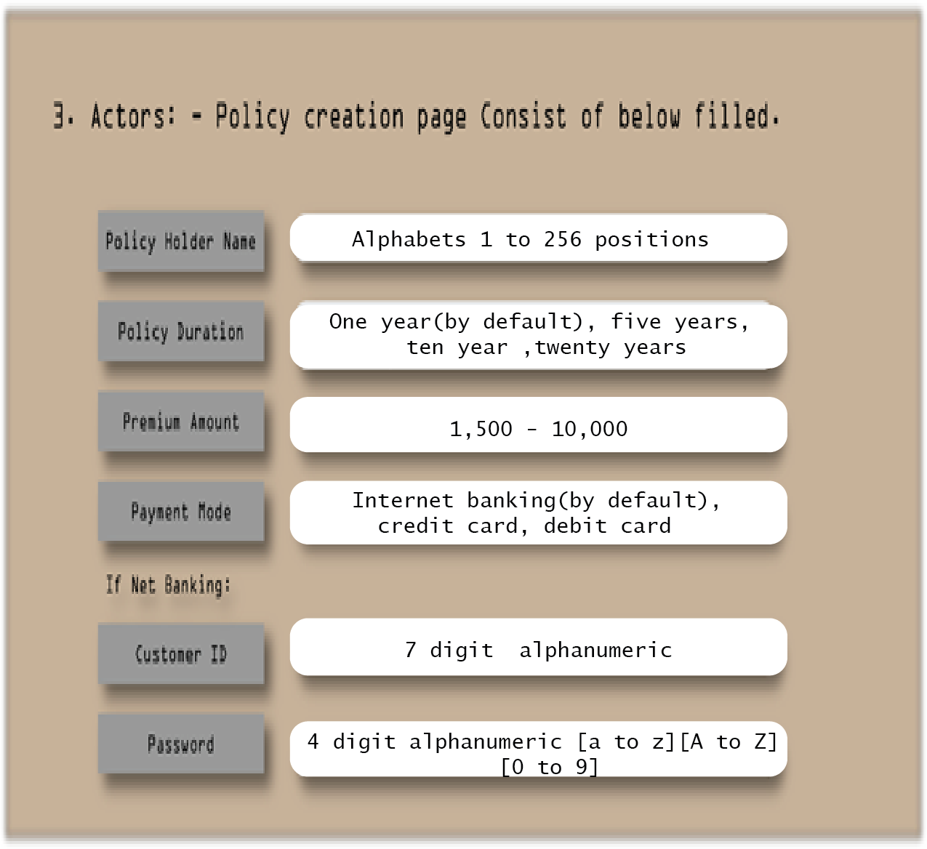

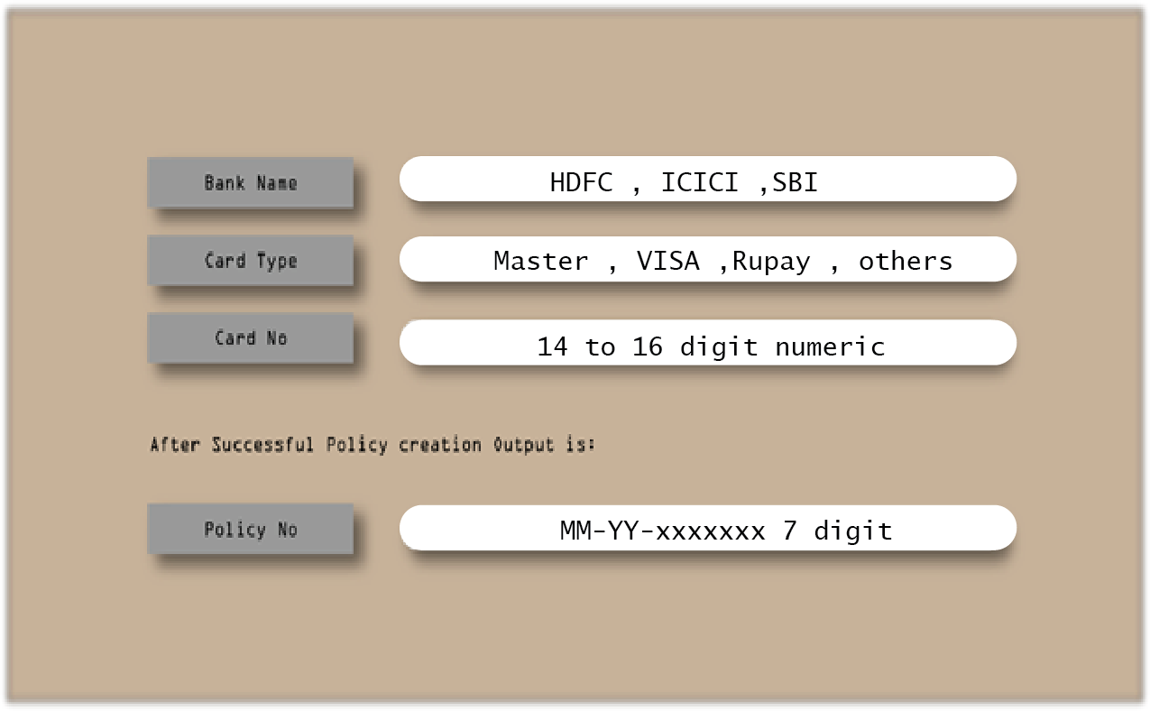

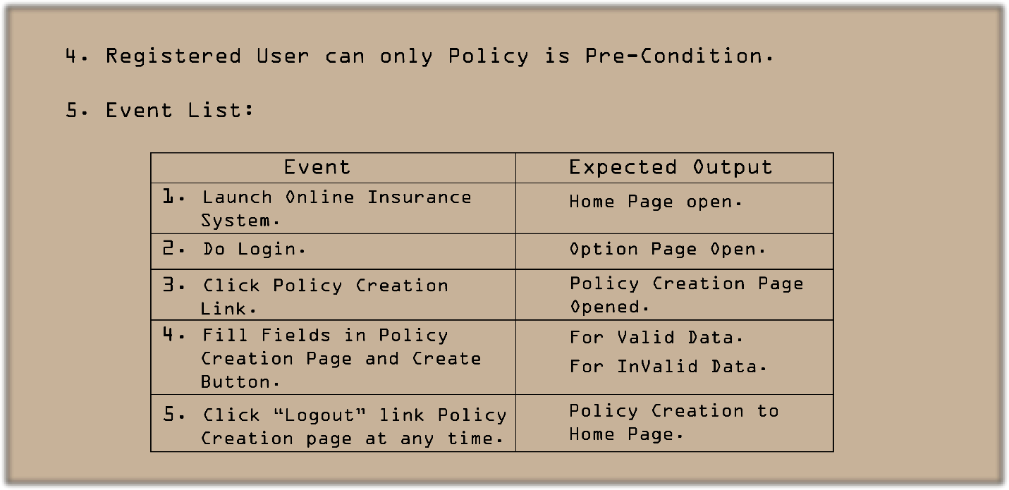

For Valid Data:

* Policy member will come as unique.
* Policy No. will go to Email ID through “E-mail”.
* Policy No. will go to Mobile through “SMS”.

For Invalid Data:

* Error Message.

6.

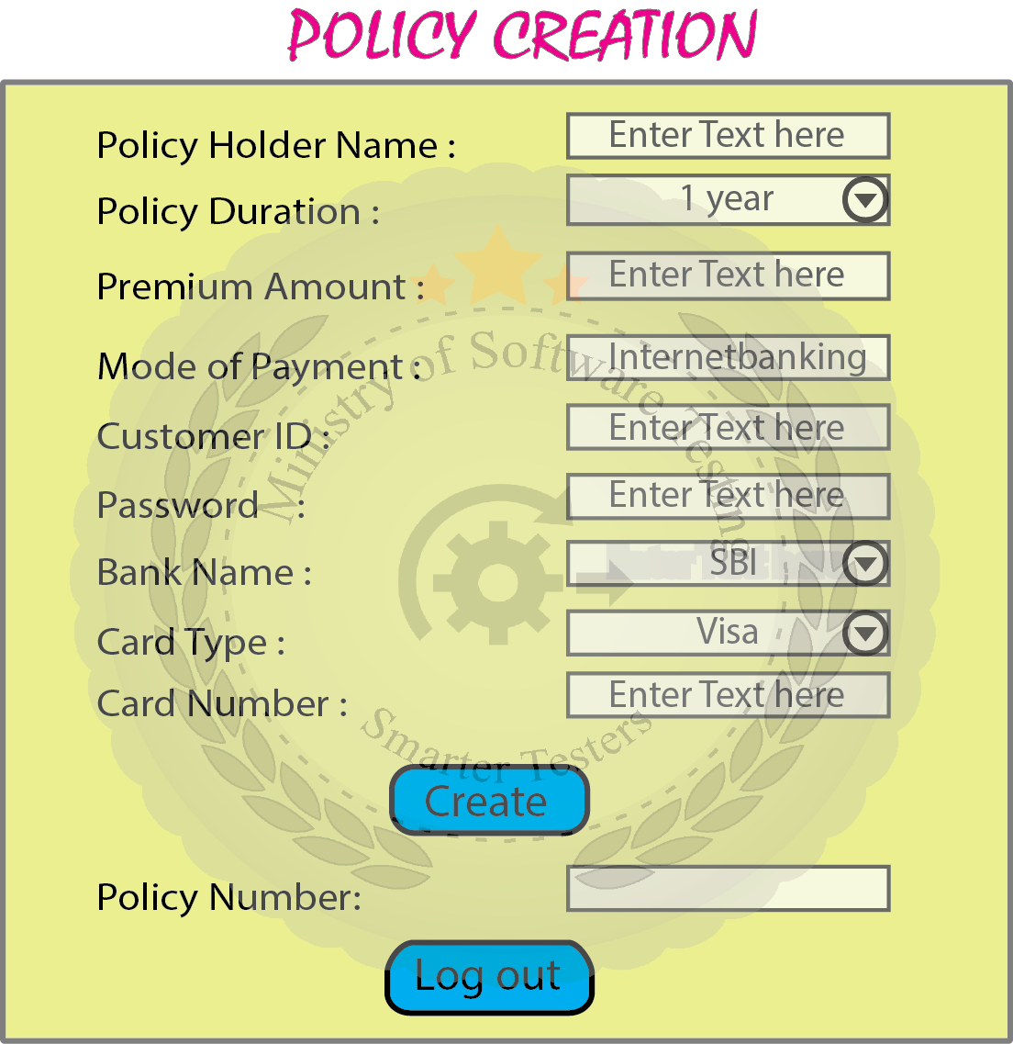

7. Post Condition: User can Click Logout Link to back to Home Page.

8. Alternative Event: - None

9. Related Modules: Registration, Login, Premium Payment Policy, and Closing.

1. **Screen based specification for Policy Creation module**





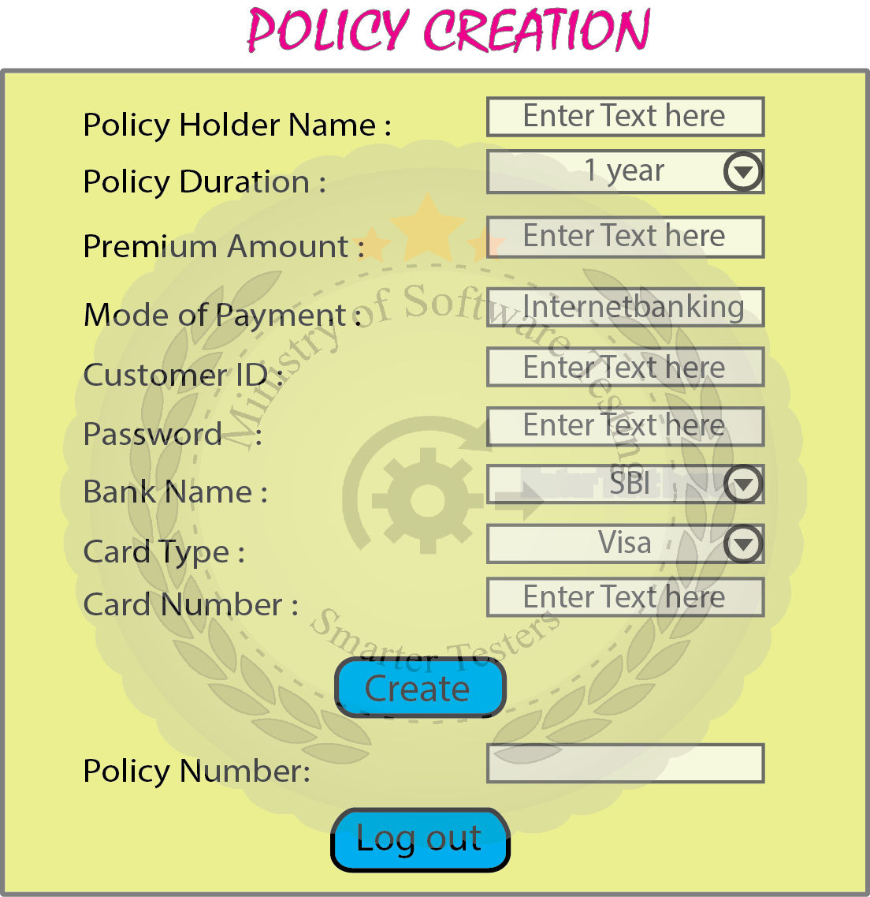

**B. Screen based specification for Premium Payment module**





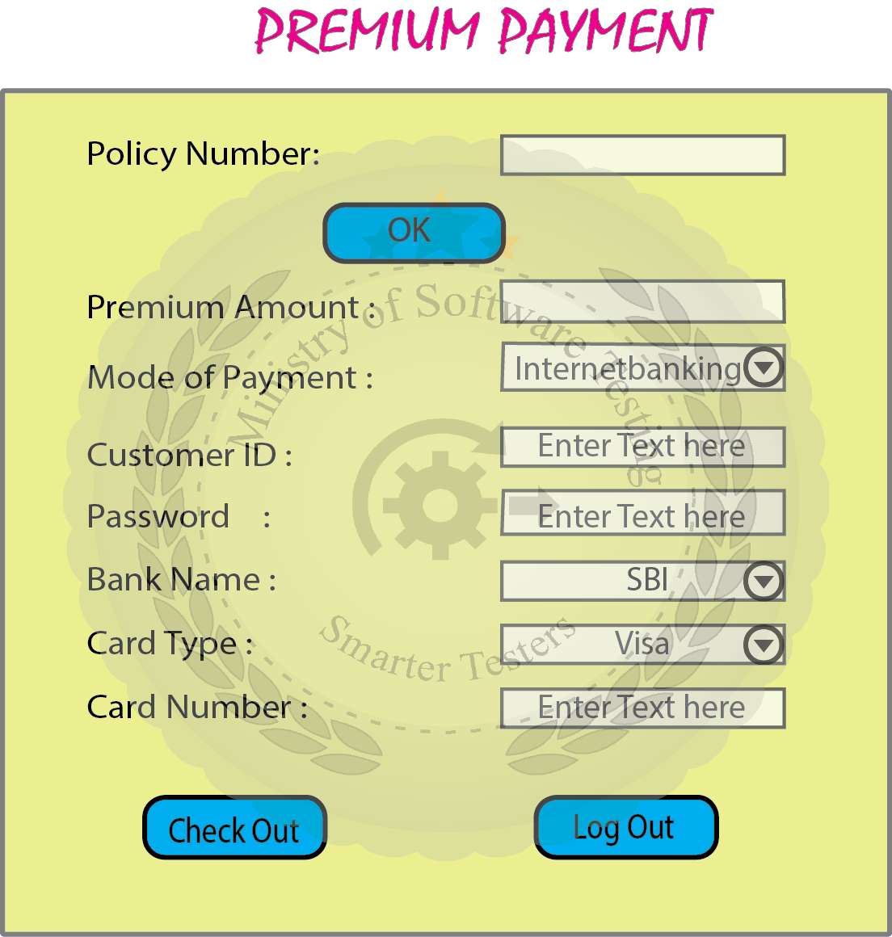

**C. Screen based specification for Policy Closing module.**





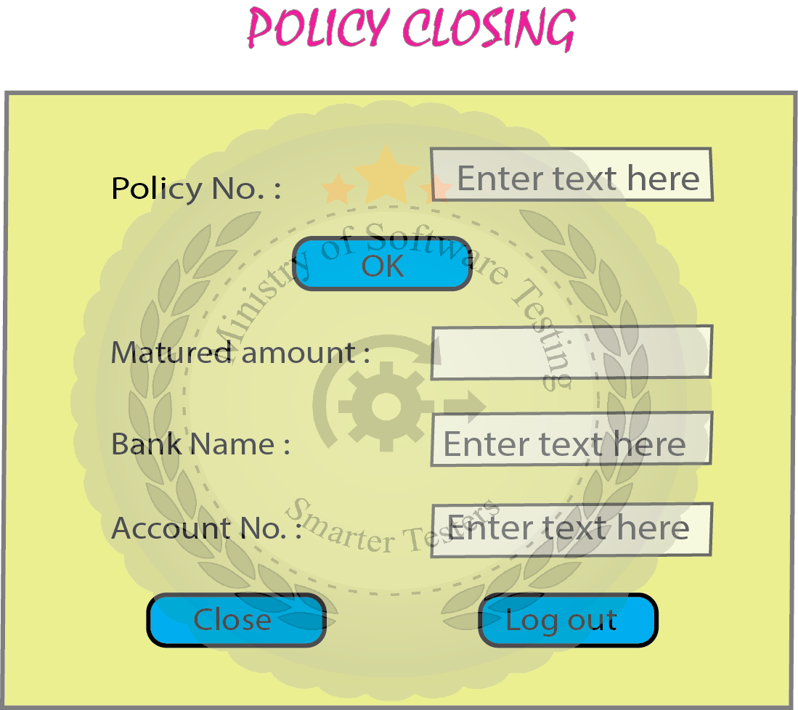

**Functional Test Scenarios**

**Functional Specifications Requirement based scenarios**

**For Registration Module**

Test scenario 1:  
- Validate “registration link” operation by clicking in home page or login page.

Test scenario 2:  
- Validate “User name” field in registration page.

Test scenario 3:  
- Validate “Full name” field in Registration page.

Test scenario 4:  
- Validate “Address” field in Registration page.

Test scenario 5:  
- Validate “Email id” field in Registration page.

Test scenario 6:  
- Validate “Mobile number” field in Registration page.

Test scenario 7:  
- Validate “Password” field in registration page.

Test scenario 8:  
- Validate “Retype password” field in Registration page.

Test scenario 9:  
- Validate registration operation by clicking Submit button.

**Functional Specifications Requirement based scenarios**

**For Login Module**

Test scenario 10:  
- Validate “User id” field in Login page.

Test scenario 11:  
- Validate “Password” field in Login page.

Test scenario 12:  
- Validate login operation by clicking “Sign in” button.

**Functional Specifications Requirement based scenarios**

**For Policy Creation Module**

Test scenario 13:  
- Validate “Policy creation “link operation by clicking in options page.

Test scenario 14:  
- Validate “Account holder name” field in Policy creation page.

Test scenario 15:  
- Validate “Policy duration” selection operation in Policy creation page.

Test scenario 16:  
- Validate “Policy amount” field in Policy creation page.

Test scenario 17:  
- Validate “Payment mode” selection operation in Policy creation page.

Test scenario 18:  
- Validate “Customer ID” field in Policy creation page when Payment mode is Net banking.

Test scenario 19:  
- Validate “Password” field in Policy creation page when Payment mode is Net banking.

Test scenario 20:  
- Validate “Bank name” selection operation in Policy creation page when Payment mode is Net banking.

Test scenario 21:  
- Validate “Card type” selection operation in Policy creation page.

Test scenario 22:  
- Validate “Card number” field in Policy creation page when Payment mode is Credit card.

Test scenario 23:  
- Validate Policy creation operation by clicking “Create “button.

Test scenario 24:  
- Validate “Policy number “format after successful creation.

Test scenario 25:  
- Validate “Logout” link operation by clicking, in Policy creation page.

**Screen/Prototype Requirement based scenarios**

**For Premium Payment Module**

Test scenario 26  
- Validate “Premium payment “link operation in Options page.

Test scenario 27  
- Validate “Policy number “field in Premium payment page.

Test scenario 28  
- Validate “Ok” button operation by clicking, to get amount to pay in Premium payment page.

Test scenario 29  
- Validate “Payment mode” selection operation by clicking, in Premium payment page.

Test scenario 30  
- Validate “Customer ID” field in Premium payment mode when payment mode is Net banking.

Test scenario 31

- Validate “Password” field in Premium payment page when Payment mode is Net banking.

Test scenario 32  
- Validate “Bank name” selection operation in Premium payment page when Payment mode is Net banking.

Test scenario 33  
- Validate “Card type” selection operation in Premium payment page.

Test scenario 34  
- Validate “Card number” field in Premium payment page when Payment mode is Credit card.

Test scenario 35  
- Validate Premium payment operation by clicking “Submit” button.

Test scenario 36  
- Validate “Log out” link operation by clicking, in Premium payment page

**Screen / Prototype based scenarios**

**For Policy Closing Module**

Test scenario 37  
- Validate “Policy closing” link operation by clicking, in Options page.

Test scenario 38  
- Validate “Policy number “field in Policy closing page.

Test scenario 39  
- Validate “Ok” button by clicking, to get mature amount in Policy closing page.

Test scenario 40  
- Validate “Bank name” selection operation in Policy closing page.

Test scenario 41  
- Validate “Account number” field in Policy closing page when Bank name selected.

Test scenario 42  
- Validate policy closing operation by clicking “Close” button in Policy closing page.

Test scenario 43  
- Validate “Log out” link operation by clicking, in Policy closing page.

Non-Functional Requirement Specification

Nonfunctional Specifications 1From Insurance company expectations Online Insurance System site is user friendly to public.  
  
Nonfunctional Specifications 2From the insurance company expectations, Online Insurance System site need to run on WINDOWS 2003 Server, WINDOWS 2008 Server, LINUX Red hat Server, and WINDOWS XP/7/8 based computers. While launching Online Insurance System site in client systems, people can use a browser like IE, Mozilla Firefox, Google Chrome, Netscape, Opera, Hot java.

Nonfunctional Specifications 3From insurance company expectations, Online Insurance System site need to run on bus topologies, ring topologies, hub topology networks. In Policy creation& Premium payment modules, receipt printout possible by using inkjet, dot-matrix& laser printers.

Nonfunctional Specifications 4

Online Insurance System site is need to provide speed with respect to insurance company

expectations. Thousand users are expected load on this website.

**Nonfunctional Test Scenarios**

Usability Testing Scenarios

Test scenario/Test case 1  
- Validate spelling check in throughout pages of OIS site.

Test scenario/Test case 2  
- Validate in it cap of labels in throughout pages of OIS site.

Test scenario/Test case 3  
- Validate meaning of labels in in throughout pages of OIS site.

Test scenario/Test case 4  
- Validate line spacing gap in between label and object uniformness in throughout pages of OIS site.

Test scenario/Test case 5  
- Validate line spacing gap in between object and object uniformness in throughout pages of OIS site.

.

Test scenario/Test case 6  
- Validate alignment of objects in throughout pages of OIS site (left, right & top, bottom).

Test scenario/Test case 7  
- Validate order or arrangement of objects with respect to functionality in throughout pages of OIS site.

Test scenario/Test case 8  
- Validate labels font size uniformness in throughout pages of OIS site.

Test scenario/Test case 9  
- Validate labels font style uniformness in throughout pages of OIS site.

Test scenario/Test case 10  
- Validate keyboard access on every object in throughout pages of OIS site.

Test scenario/Test case 11  
- Validate format visibility for date objects in throughout pages of OIS site.

Test scenario/Test case 12  
- Validate existence of progress bar/ status bar like objects in throughout pages of OIS site to

indicate background process.

Test scenario/Test case13  
- Validate icon symbols with respect to functionality in throughout pages of OIS site.

Test scenario/Test case14  
- Validate icon symbol & displaying tool tip with respect to functionality in OIS site.

Test scenario/Test case15  
- Validate the existence of system menu in throughout pages of OIS site.

Test scenario/Test case16  
- Validate color contrast in between objects with respect to functionality in throughout pages of

OIS site.

Test scenario/Test case17  
- Validate meaning of shortcut labels for every objects in throughout pages of OIS site.

Test scenario/Test case18  
- Validate meaning of error messages will come in throughout pages of OIS site.

Test scenario/Test case19  
- Validate help message given by developers in throughout pages of OIS site.

Compatibility Testing Scenarios

Test scenario 1  
- Validate “Registration” operation in customer expected platforms.

Test scenario 2  
- Validate “Login” operation in customer expected platforms.

Test scenario 3  
- Validate “Policy creation” operation in customer expected platforms.

Test scenario 4  
- Validate “Premium payment” operation in customer expected platforms.

Test scenario 5  
- Validate “Policy closing” operation in customer expected platforms.

Hardware Configuration Requirements Testing Scenarios

Test scenario 1  
- Validate “Registration” operation with customer expected hardware configurations.

Test scenario 2  
- Validate “Login” operation with customer expected hardware configurations.

Test scenario 3  
- Validate “Policy creation” operation with customer expected hardware configurations.

Test scenario 4  
- Validate “Premium payment” operation with customer expected hardware configurations.

Test scenario 5  
- Validate “Policy closing “operation with customer expected hardware configurations.

Performance Testing Scenarios

Test scenario 1  
- Validate “Registration” operation by applying different load levels.

Test scenario 2  
- Validate “Login” operation by applying different load levels.

Test scenario 3  
- Validate “Policy creation” operation by applying different load levels.

Test scenario 4  
- Validate “Premium payment” operation by applying different load levels.

Test scenario 5  
- Validate “Policy closing” operation by applying different load levels.